Sine Functions Practice Questions

1) Sketch the following functions
a) $f\left(x\right)=2\sin{x}+2$ | b) $f\left(x\right)=5\sin{(x+3)}-5$
c) $f\left(x\right)=-3\sin{(π(x}-3))+6$ | d) $f\left(x\right)=0.5\sin\left(\frac{π}{4}\left(x+2\right)\right)$

2) Determine the solution set for each of the trigonometric equations below
- $2\sin\left(2\left(x-\frac{π}{6}\right)\right)=\sqrt{3} if x∈\left[-3π, 3π\right]$

- $3\sin\left(\frac{π}{6}\left(x+5\right)\right)-7=0 if x∈\left[0, 48\right]$

- $4\sin\left(2\left(x-\frac{π}{7}\right)\right)=-2$

- $2\sin\left(\frac{π}{2}\left(x-1\right)\right)+2\sqrt{3}=\sqrt{3}$

3) Find the zeros of the functions whose rules are:
- $f\left(x\right)=\sin{x}+0.5$

- $f\left(x\right)=-\sin{2x}-\frac{\sqrt{2}}{2}$

- $f\left(x\right)=3\sin\left(π\left(x-1\right)\right)+3$

- $f\left(x\right)=-5\sin\left(0.5\left(x+π\right)\right)-10$

4) Determine the solution set for each of the trigonometric inequalities below
- $4\sin\left(4x\right)-3>-5 if x∈\left[-π, π\right]$

- $6\sin\left(x+π\right)-3\sqrt{3}<0 if x∈\left[-3π, 3π\right]$

5) A person is working out with a skipping rope. The height H (in cm) of the middle of the rope in relation to the ground varies according to the rule $H=150\sin\left(\frac{8π}{3}x\right)+152.5$ where x represents time (in s). This person’s feet are off the ground when the height of the rope is 22.6 cm or less. If a workout lasts 5 min:
- How many times does this person jump during this workout session?
- How long are this person’s feet off the ground during this workout session?

6) At an ocean port, the water has a maximum depth of 4 m above the mean level at 8am and the period is 12.4 h.
- Assuming that the relation between the depth of the water and time is a sinusoidal function, write an equation for the depth of the water at any time, t.
- Find the depts of the water at 10am

7) Find the rule for each of the following graphs in the form $f\left(x\right)=a\sin{b\left(x-h\right)}+k$

a)  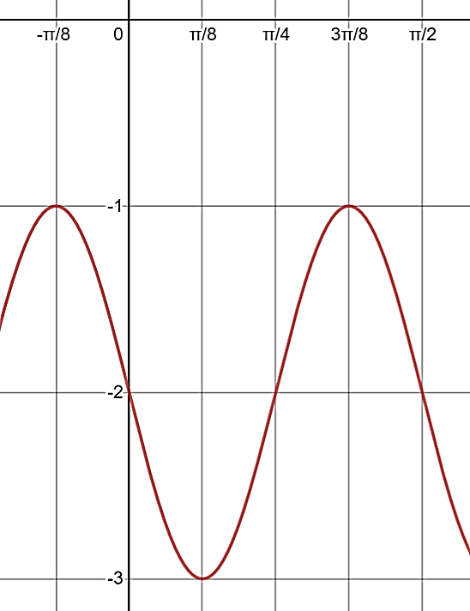 | b)  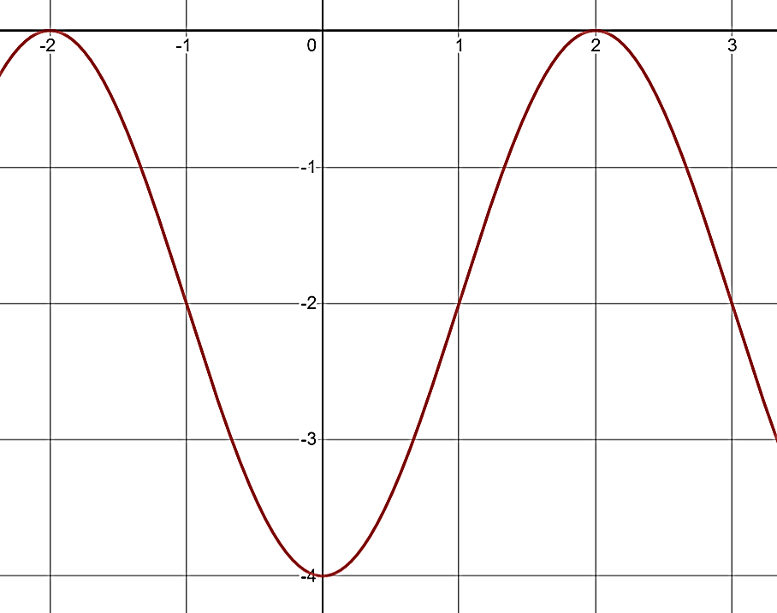
c)
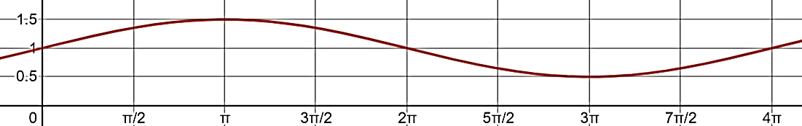

8) In an ecosystem, a reduction in the number of prey leads to a reduction in the number of predators. When predators are less numerous, the number of prey begins to increase, which leads to an increase in the number of predators and so on.

Consider the following information on the evolution of the number of deer and the number of coyotes in an ecosystem since the year 2000

Deer Population  In 2000, the deer population reached its lowest level, 180 animals  In 2004, the deer population reached its highest level, 240 animals  In 2008, the deer population again reached its lowest level  The deer population varies as a function of time (in years) as a function of a sinusoidal function | Coyote Population  In 2001, the coyote population reached its lowest level, 16 animals  In 2005, the coyote population reached its highest level, 24 animals  In 2009, the coyote population again reached its lowest level  The coyote population varies as a function of time (in years) as a function of a sinusoidal function
- Determine a rule that allows you to calculate:
  - The deer population as a function of the amount of time elapsed since the year 2000
  - The coyote population as a function of the amount of time elapsed since the year 2000
- If the trend continues
  - What will the deer population be in 2023?
  - What will the coyote population be in 2027?

