STA306 Chapter 6 Test: Nutrition and Associated Systems
Name; _____________________________Grp:_____
Part A: Multiple Choice (4 marks each, 48 marks)
- What three components of our diet provide us with fuel for energy?
- Carbohydrates, Fat and Protein
- Carbohydrates, Fat and Vitamins
- Carbohydrates, Vitamins and Minerals
- Fat, Vitamins and Water

- Which component of our diet builds, maintains and repairs our tissues?
- Carbohydrates
- Fat
- Protein
- Vitamins and Minerals

- Where does the chemical digestion of the carbohydrate starch begin?
- Mouth
- Stomach
- Small intestine
- Large intestine

- Where does the chemical digestion of protein begin?
- Mouth
- Stomach
- Small intestine
- Large intestine

- Which organ of the digestive tract is responsible for the reabsorption of water?
- Mouth
- Stomach
- Small intestine
- Large intestine

- During inhalation:
- the intercostal muscles and diaphragm relax.
- the air volume in the lungs decreases.
- the air pressure in the lungs decreases.
- all of the above occurs.

- These vessels of the Cardiovascular System carry blood to the heart.
- Arteries
- Capillaries
- Veins
- Ventricles

- Which formed element is responsible for carrying oxygen in the blood using hemoglobin?
- Red blood cells
- Platelets
- Plasma
- White blood cells

- What blood type would Sarah have if Anti A and Anti Rh sera caused it to clump?
- A- b) A+ c) B+ d) AB+

- If Ryan had B- type blood, what blood types could he donate to?
- B-, O-
- B-, B+, O-, O+
- A+, B-, AB-, AB+
- B-, B+, AB-, AB+

- If Athena had A+ type blood, what blood types could she receive from?
- A+, O-
- A-, A+, O-, O+
- A+, AB+
- A-, A+, AB-, AB+

- Which is the correct order for the production and circulation of urine through the urinary system?
- Kidney urethrabladder ureter
- Bladder kidney ureter urethra
- Kidney bladder ureter urethra
- Kidney ureter bladder urethra

Place Multiple Choice Answers Here:
- _____ 2. _____ 3. _____ 4. _____ 5. _____ 6. _____
7. _____ 8. _____ 9. _____ 10. _____ 11. _____ 12. _____
Part B: Labelling Diagrams (40 marks)
- Label the anus, esophagus, gallbladder, gastric glands, intestinal glands, large intestine, larynx, liver, mouth, pancreas, pharynx, salivary glands, stomach, rectum and small intestine in the following diagram of the digestive system. (15 marks)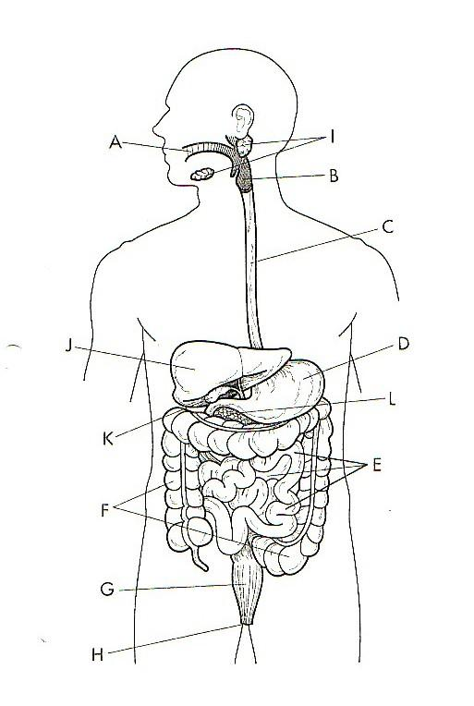

- The Respiratory System: 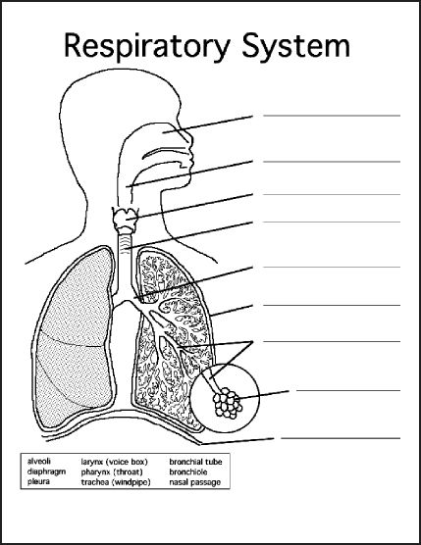

- The Cardiovascular System: Include the aorta, left atrium, left ventricle, right atrium, right ventricle, pulmonary artery, pulmonary vein, inferior vena cava and superior vena cava. (9 marks)
Include an indication of the blood flow through the heart with arrows and whether the blood is rich in O₂ (red) or CO₂ (blue) (6 marks).
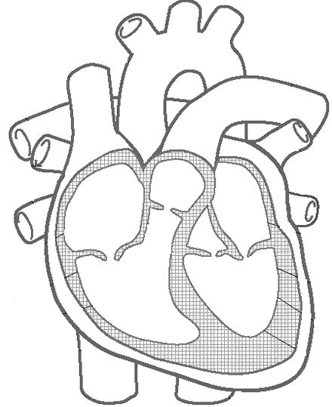

Part C: Constructed Responses (12 marks)
- What are the final products of digestion for absorption from each below? (3 marks)
- Carbohydrates __________________________________________
- Protein _______________________________________
- Fat ____________________________________
- Name three substances dissolved in blood plasma: ( 3 marks) ___________________________________________________________________
- What is the function of oxygen in our body? (3 marks)
______________________________________________________________________________________________________________________________________
.
- What is the function of the Lymphatic system? Include the function of lymphatic nodes. (3 marks) __________________________________________________________________
__________________________________________________________________
Bonus questions (4 bonus marks):
Spell the device that measures blood pressure. _______________________________________________
Give the scientific name for RBCs, WBCs and platelets. _________________________
______________________________________________________________________

