Card 6
The old town of Königsberg has seven bridges.
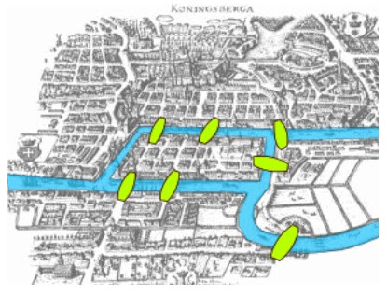

Can you take a walk and visit each part of the town (as many times as necessary) and crossing each bridge once and only once?

Card 6
The old town of Königsberg has seven bridges.

Can you take a walk and visit each part of the town (as many times as necessary) and crossing each bridge once and only once?

Card 6 Hint
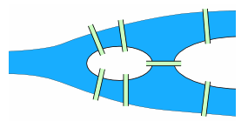
We can simplify the map. There are four areas of the town – on the mainland north of the river, on the mainland south of the river, on the island in the center of the map, and on the peninsula (the piece of land on the right of the map between the rivers).

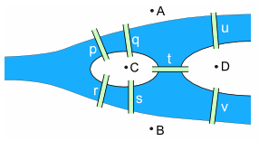
Let’s label the land masses A, B, C, and D.

To visit each part of town, we need to visit A, B, C, and D at least once.

We also need to cross the bridges once and only once.
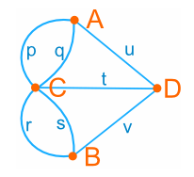
Let’s label the bridges p, q, r, s, t, u, and v.

We can further simplify it to this. Now can you use what you’ve learned about Graph Theory to answer the question?

Card 6 Hint
We can simplify the map. There are four areas of the town – on the mainland north of the river, on the mainland south of the river, on the island in the center of the map, and on the peninsula (the piece of land on the right of the map between the rivers).

Let’s label the land masses A, B, C, and D.

To visit each part of town, we need to visit A, B, C, and D at least once.

We also need to cross the bridges once and only once.
Let’s label the bridges p, q, r, s, t, u, and v.

We can further simplify it to this. Now can you use what you’ve learned about Graph Theory to answer the question?

Card 1
Can you draw each shape without removing your pencil from the paper and tracing each line only once? You may start at any point. Copy the shape and your answers into your notebook.

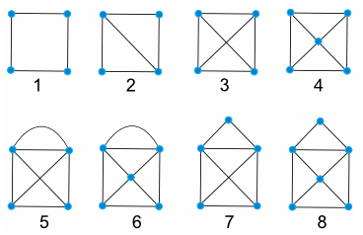

Card 1
Can you draw each shape without removing your pencil from the paper and tracing each line only once? You may start at any point. Copy the shape and your answers into your notebook.

Card 2

Copy these notes and diagrams into your notebook

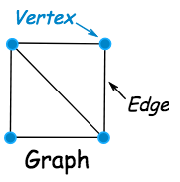
- A point is called a vertex (plural: vertices)
- A line is called an edge
- The whole diagram is called a graph
- The number of edges that lead into a vertex is called the degree
- An Euler path is a path that visits every edge in a graph just once

Card 2

Copy these notes and diagrams into your notebook

- A point is called a vertex (plural: vertices)
- A line is called an edge
- The whole diagram is called a graph
- The number of edges that lead into a vertex is called the degree
- An Euler path is a path that visits every edge in a graph just once

Card 3
Copy these notes and diagram into your notebook.

We can label our vertices and our edges. Vertices are generally labeled with letters, numbers, or words. Edges are typically labeled by combining the labels of the vertices that are the endpoints of the edge (in any order)

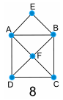
Going back to Figure 8 (from Card 1):
- There are 6 vertices: A, B, C, D, E, and F
- There are 10 edges: AB, BC, CD, DA, AF, BF, CF, DF, AE, and BE
- Vertices A, B, and F have degree 4
- Vertices C and D have degree 3
- Vertex E has degree 2
- There is an Euler path around this graph. Can you find it? (Hint: start at either C or D).

Card 3
Copy these notes and diagram into your notebook.

We can label our vertices and our edges. Vertices are generally labeled with letters, numbers, or words. Edges are typically labeled by combining the labels of the vertices that are the endpoints of the edge (in any order)

Going back to Figure 8 (from Card 1):
- There are 6 vertices: A, B, C, D, E, and F
- There are 10 edges: AB, BC, CD, DA, AF, BF, CF, DF, AE, and BE
- Vertices A, B, and F have degree 4
- Vertices C and D have degree 3
- Vertex E has degree 2
- There is an Euler path around this graph. Can you find it? (Hint: start at either C or D).

Card 4
Go back to Figures 1-8. Determine if there is an Euler Path, the number of vertices, how many vertices with an odd degree, and how many vertices with an even degree. Copy the table below and fill it in.
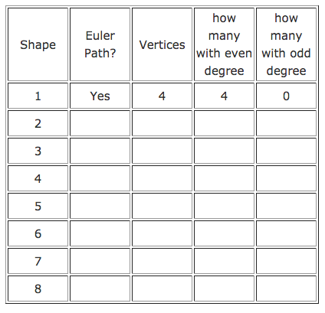

Card 4
Go back to Figures 1-8. Determine if there is an Euler Path, the number of vertices, how many vertices with an odd degree, and how many vertices with an even degree. Copy the table below and fill it in.

Card 5
Which of the following graphs have Euler Paths?
From these graphs and the previous ones, what can you determine about the connection between Euler paths and vertices?
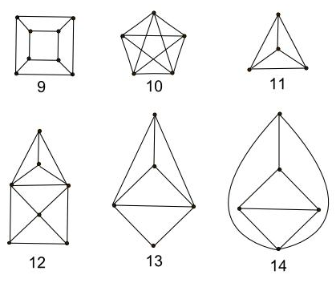

Card 5
Which of the following graphs have Euler Paths?
From these graphs and the previous ones, what can you determine about the connection between Euler paths and vertices?

