Name______________________ Group__________ /36

Sine Function Assignment

1. Over what intervals does the basic sin function increase?

(4 pts)

2. The following statements were made regarding the function $f\left(x\right)=-2 sin\left(\frac{π}{2}\left(x-4\right)\right)+2$ Which statement is correct? (Tip: Graph it!)

(4 pts)

|  |  |
| --- | --- |
| A) | It increases on $\left[0, 1\right]$ and decreases on $\left[3, 5\right]$ |
| B) | It decreases on $\left[0, 1\right]$ and increases on $\left[3, 5\right]$ |
| C) | It increases on $\left[1, 3\right]$ and decreases on $\left[7, 9\right]$ |
| D) | It decreases on $\left[1, 3\right]$ and increases on |

3. The expression  is equivalent to

(4 pts)

|  |  |  |  |
| --- | --- | --- | --- |
| A) |  | C) | sin A |
| B) | cos A | D) |  |

4. The expression  is equivalent to

(4 pts)

|  |  |  |  |
| --- | --- | --- | --- |
| A) | cos *x* | C) | sec *x* |
| B) | sin *x* | D) | cosec *x* |

5. What is the rule of the sine function graphed below?

(4 pts)

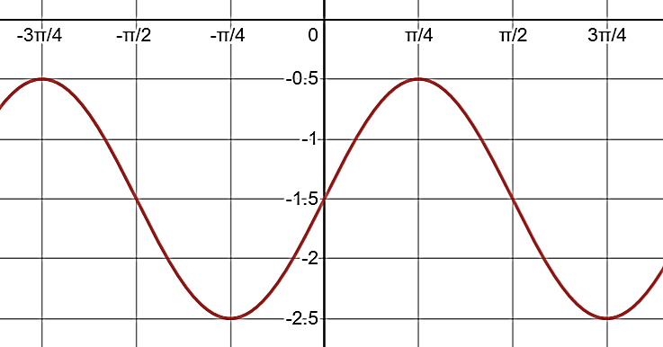

6. During an experiment, the intensity i*(t)* of the electric current of a device as a function of time *t* elapsed since the beginning of the experiment is given by:

*i(t)* = 6 sin  where *t* is expressed in seconds.

The device emits a sound signal each time the current’s intensity is equal to 9. The experiment lasts 120 seconds. How many sound signals does the device emit during the experiment?

(8 pts)

7. A fountain in a shopping centre has a single jet of water. The height of the jet of water varies according to a sinusoidal function. Joel notes that, in exactly one minute, the jet goes from a minimum height of 1 m to a maximum height of 5 m and back to 1 m. At 13:00, the jet of water is at a height of 1 m.

What will be the height of the jet of water, to the nearest tenth of a metre, when the clock reads 13:12:40? (13 hours, 12 minutes, 40 seconds)

(8 pts)