Equation 1  $$2y=6x-4$$ | Equation 2  $$4y+4x=8$$ | Solving Systems of Equations by Graphing
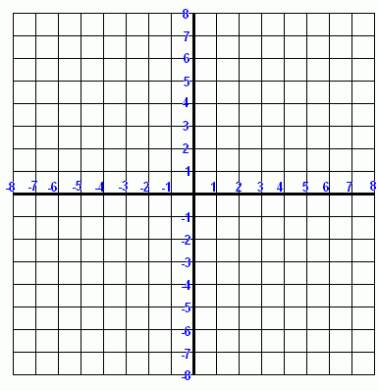 | Equation 1:  Equation 2:
Solution
( , )

 | Glue only this section  into your notebook. | 1) Change both equations to  $y=ax+b$
 |  | 2) Sketch both lines on the same graph
 |  | 3) The point where the lines intersect is the solution

